

**Tribhuvan University**

**Faculty of Humanities and Social Science**

**Internship Report On**

**“Associate Software Engineer”**

At

**Biiyond Production Pvt. Ltd.**

**Submitted to**

**Department of Computer Application**

**Triton International College**

# *In partial fulfillment of the requirements for the Bachelors in Computer Application*

Submitted by

Aashutosh Kattel (6-2-529-1-2020)

April 2025

Under the Supervision of

**Er. Shiva Shankar Sah**



**Tribhuvan University**

**Faculty of Humanities and Social Science**

**Triton International College**

**Supervisor’s Recommendation**

I hereby recommend that this internship report prepared under my supervision by **Er. Shiva Shankar Sah** entitled “**Associate Software Engineer**” in the Partial Fulfillment of requirement for the degree of Bachelors in Computer Application is recommended for that final evaluation.

**…………………………**

**Er. Shiva Shankar Sah**

**Supervisor**



**Tribhuvan University**

**Faculty of Humanities and Social Science**

**Triton International College**

**LETTER OF APPROVAL**

This is to certify that the internship report prepared by Aashutosh Kattel entitled “**Associate Software Engineer**” in the partial fulfillment of the requirements for the degree of Bachelors in Computer Application has been well studied. In our opinion it is satisfactory in the scope and quality as a project for the required degree.

|  |  |
| --- | --- |
| **…………………..**  Er. Shiva Shankar Sah  Supervisor  Triton Int’l College | **…………………..**  Milan Baral  Coordinator  Triton Int’l College |
| **…………………..**  Chiranjibi Ban  Internship Mentor | **…………………..**  External Examiner |

ii

**ACKNOWLEDGEMENT**

First and foremost, I would like to thank our esteemed mentor, **Chiranjibi Ban,** for this invaluable guidance and support throughout the program. His expertise in software engineering, as well as his patient and supportive teaching style, were instrumental in helping me to achieve my goals.

I convey my sincere gratitude to my academic supervisor, **Shiva Shankar Sah,** academic advisor of Triton International College. Without his kind direction and proper guidance this study would have been a little success. In every phase of the project his supervision and guidance shaped this report to complete perfection.

I am grateful to our colleagues at **Biiyond Production Pvt. Ltd.** for their support and encouragement. Their willingness to share their knowledge and experience helped me to gain a better understanding of the real-world application of Python.

Thank you all for your contributions to the success of the internship program. I am deeply grateful and look forward to applying what I have learned in the future.

iii

**ABSTRACT**

This report is the full document of the project of a web-based software developed during the three months internship period. Advanced Grammar Checker is a web-based software built using Python-Streamlit. This application is developed as a stand alone application (later integrated to main application).

NLP is the principle that backs the entire system. This software is developed for teachers and students (english learners). Strict software engineering practices are followed to ensure robustness of the software.

***Keywords: Python, Streamlit, Software Engineering, NLP***

iv

**TABLE OF CONTENTS**

**SUPERVISORS RECOMMENDATION ........................................................................ i**

**LETTER OF APPROVAL …………............................................................................... ii**

**ACKNOWLEDGEMENT ................................................................................................iii**

**ABSTRACT ...................................................................................................................... iv**

**TABLE OF CONTENTS .................................................................................................. v**

**LIST OF ABBREVIATIONS ......................................................................................... vii**

**LIST OF FIGURES ........................................................................................................ viii**

**LIST OF TABLES ............................................................................................................ ix**

# CHAPTER 1: INTRODUCTION ..................................................................................... 1

1.1 Introduction........................................................................................................... 1

1.2 Problem Statement ................................................................................................ 1

1.3 Objectives .............................................................................................................. 1

1.4 Scope and Limitation............................................................................................ 2

1.4.1 Scope.............................................................................................................. 2

1.4.2 Limitations..................................................................................................... 2

1.5 Report Organization .............................................................................................. 2

# CHAPTER 2: INTRODUCTION TO ORGANIZATION ............................................. 4

2.1 Organization Details.................................................................................................... 4

2.2 Organizational Hierarchy ........................................................................................... 5

2.3 Working Domains of Organization ............................................................................ 5

2.4 Description of Intern Department/Unit ...................................................................... 6

# CHAPTER 3: BACKGROUND STUDY AND LITERATURE REVIEW ................... 7

3.1 Background Study ...................................................................................................... 7

3.2 Literature Review...................................................................................................... 7 **CHAPTER 4: INTERNSHIP ACTIVITIES ...................................................................... 8**

4.1 Roles and Responsibilities ........................................................................................... 8

4.2 Weekly Log .................................................................................................................. 9

4.3 Description of the Project(s) Involved During Internship ......................................... 10

4.4 Tasks / Activities Performed ..................................................................................... 10

# CHAPTER 5: CONCLUSION AND LEARNING OUTCOMES ................................ 12

5.1 Conclusion ................................................................................................................ 12

5.2 Learning Outcome ......................................................................................./............ 12

**References ......................................................................................................................... 13**

**Appendix**

vi

# LIST OF ABBREVIATIONS

|  |  |
| --- | --- |
| CSS | Cascading Style Sheet |
| AGC  MySQL  JS  API  NLP | Advanced Grammar Checker  Structured Query Language  JavaScript  Application Programming Interface  Natural Language Processing |
|  |  |
|  |  |

vii

LIST OF FIGURES

Figure 2.1: Company logo…………..................................................................................... 4

Figure 2.2: Organizational Hierarchy of Biiyond ................................................................. 5

viii

LIST OF TABLES

Table 2.1: Internship Duration ............................................................................................. 6

Table 4.1: Weekly Log……………………………………………………………………10

ix

**CHAPTER 1:**

**INTRODUCTION**

## 1.1 Introduction

As an Associate Software Engineer Intern at Biiyond Production Pvt. Ltd, opportunities arose to work with software engineering practices. Throughout the time working with frontend development, valuable experience and knowledge were gained about SE and NLP. One of the first projects was AGC, a simple application teacher and student to test/check the writing skills. NLP libraries made it easy to create the necessary components for a modular and maintainable system architecture. This involved building various components each with its own specific functionalities and interactions. The experience working with software engineering was extremely positive, making it easy to build robust applications quickly and efficiently, resulting in a lot of valuable knowledge and experience gained during the internship.

## 1.2 Problem Statement

There are many potential problems that can arise when using React to develop a project.

* Lack of experience with Streamlit: Being new to streamlit, challenges may be encountered while learning the framework and trying to build projects.
* Integration Complexity: Managing NLP based applications, especially in larger projects, can become convoluted and challenging to maintain, leading to codebase complexity and potential bugs.
* NLP Accuracy: Ensuring proper implementation of NLP libraries/ training custom models.

As an intern tasked with developing a project using Python, the primary objective is to leverage the capabilities of the Streamlit framework to create a robust and scalable application solution.

## 1.3 Objectives

* To implement frontend technologies using Streamlit-Python.
* To learn how to use other tools and technologies commonly used such as git.
* To learn to integrate NLP functionality.

## 1.4 Scope and Limitation

### 1.4.1 Scope

Software engineering has a broad scope that includes designing and developing the end to end applications. Some of the scopes are

* Collaborate with the development team to design and develop software using Frameworks like Streamlit and Python.
* Write clean, well-documented and maintainable code that follows industry best practices and standards.
* Participate in code reviews and contribute to improving the overall quality of the codebase.
* Troubleshoot and debug issues reported by end-users or detected during testing.

### 1.4.2 Limitations

* Limited access to real projects: Depending on the size and nature of company, interns may not have access to the same level of projects as full-time developers.
* Limited exposure to advanced concept: Although interns will be given the opportunity to learn about software engineering, they may not have exposure to more advanced concepts in SE due to time and resource constraints.
* Limited time for independent projects: The internship period is usually limited, which may not provide enough time for interns to work on independent projects or undertake more complex tasks that require more time to complete.

## 1.5 Report Organization

### Introduction

Chapter explains the introduction to study, problem statement, and objective of the study, scope and limitation of study.

### Introduction to Organization

The second chapter is concern with the organization detail, organizational hierarchy, working domains of organization, description of intern development/unit.

### Background Study and Literature Review

This chapter specify the background study description of fundamental theories, general concepts and terminologies related to internship project. Literature review of the similar projects during internship, theories and results with similar projects during internship.

### Internship Activities

This chapter include Roles and Responsibilities, weekly log (technical details of activities), description of the project involved during intern and task / activities performed.

### Conclusion and Learning Outcomes

This chapter specify the conclusion and learning outcomes of the internship.

**CHAPTER 2:**

**INTRODUCTION TO ORGANIZATION**

## 2.1 Organization Details

Biiyond Productions is a pioneer in modern Information Management System (IMS) development in Nepal and as collaborated with the Government of Nepal for the development of information management system on disaster information management, human rights etc. Likewise, Biiyond has been carrying out Digital Mapping through the engagement of Digital Volunteers.



### *Figure 2.1: Company logo*

Biiyond Production is focused on technology development, disaster risk reduction, climate change, open data, entrepreneurship, data driven advocacy, youth engagement, and volunteerism. Biiyond has a sound expertise in following six thematic sectors: Digital Mapping, Information Management System, Research and Publication, Digital Survey and Mapping, Training and Capacity Development, Governance and Policy.

## 2.2 Organizational Hierarchy



CEO



CTO



Director



Manager



Engineer



Intern



Associate

### *Figure 2.2: Organizational Hierarchy*

1. CEO (Chief Executive Officer): The top executive who sets the company's overall strategy and vision.
2. CTO (Chief Technology Officer): Responsible for the company's technology strategy, research and development, and product development.
3. Director: Manages a department or team within the company, such as software development, quality assurance, or human resources.
4. Manager: Oversees a team of employees within a specific department or function, such as software engineering.
5. Engineer: The technical staff responsible for designing, developing, testing, and maintaining software products.
6. Associate: Entry-level employees who work under the supervision of engineers performing tasks such as testing, documentation and customer support.
7. Intern: Interns are potential employees that are usually undergraduates or students who are given exposure to working environment within a specific work environment.

## 2.3 Working Domains of Organization

* Software Development: This involves in designing, engineering, testing and maintaining software applications for various industries and purposes.
* Web Development: This involves in building and maintaining websites, web applications, and other online platforms.
* Graphic Designing: It involves in creating visual content to communicate information or messages to a specific audience.
* IT consulting: It involves providing advice and guidance on IT strategy, implementation, and management.
* Digital Marketing: This includes using online channels to promote products and services, such as social media marketing, search engine optimization, and email marketing.

## 2.4 Description of Intern Department/Unit

During the internship at Biiyond Production Pvt. Ltd., work was done in software engineering department. This department is responsible for designing and developing the organization's and client’s applications. This includes tasks such as redesigning and updating the website, implementing new features and functionalities, and testing and debugging the application to ensure proper functionality.

As an intern in the software engineering department, responsibilities included assisting with the redesign and implementation of the company’s website, as well as testing and debugging theapplication to ensure it was functioning correctly. Additionally, there were opportunities to work on small web development projects, such as creating and updating web pages or implementing simple features.

In addition to specific tasks and responsibilities, there was also the chance to work with and learn from the web development team, which consists of experienced professionals with a range of skills and expertise. This provided valuable insights and knowledge about the field of web-app-development and contributed to the development of skills in this area.

***Table 2.2: Internship Duration***

|  |  |
| --- | --- |
| Start Date | November 2024 |
| End Date | Jan 2025 |
| Duration | 3 Months |
| Office hours | 9:30 AM – 5:30 PM |

**CHAPTER 3:**

**BACKGROUND STUDY AND LITERATURE REVIEW**

## 3.1 Background Study

Internship is a period of work experience offered by an employer to potential employees, called interns that are usually undergraduates or students. Internship give students exposure to the working environment, often within a specific industry, which relates to their field of study.

Internships can be as short as a month or as long as 12 months. Interns can be paid of not depends on the company. Internship should give students practical skills, experience and greater knowledge of an industry, in exchange for the employer benefiting from their labor. With the emphasis firmly on training, internships give students real-life experience of the workplace and field they hope to break into.

I took an internship at “Biiyond Production Pvt. Ltd.” for 3 months. During this internship, I had great opportunities and experiences. From this internship program, I implemented many things in real life situation especially in the Information and technology sector. I implemented about time management, responsibility, how to improve team work, finding bugs, communication and etc.

## 3.2 Literature Review

Python is a high-level programming language created by Guido van Rossum that has transformed software development practices worldwide. Released in 1991, Python rapidly gained adoption due to its readability, versatility, and comprehensive standard library (Van Rossum, 1995). Unlike many programming languages that prioritize performance over syntax, Python emphasizes code readability and maintainability, allowing developers to express concepts in fewer lines of code than would be possible in languages like C++ or Java. This philosophy enhances developer productivity, reduces debugging time, and facilitates collaboration across development teams (Sanner, 1999).

Python's extensive ecosystem of libraries and frameworks efficiently supports diverse applications ranging from web development to scientific computing, making it an ideal choice for both rapid prototyping and production environments (McKinney, 2010). Furthermore, Python's community-driven development model has fostered a vibrant ecosystem of over 300,000 packages available through the Python Package Index (PyPI), providing solutions for virtually any programming challenge encountered in modern software development (Wang et al., 2019).

Streamlit, an open-source Python library launched in 2019, has revolutionized the development of data applications by simplifying the creation of interactive web interfaces. Non-web developers, particularly data scientists and machine learning engineers, can leverage Streamlit to transform Python scripts into shareable web applications with minimal effort and without knowledge of front-end technologies (Treuille, Teixeira, & Kelly, 2021). Through its declarative programming model, Streamlit enables the rapid development of data-driven applications, allowing organizations to bridge the gap between data analysis and stakeholder engagement (Chen & Davis, 2022).

Software engineering practices have evolved significantly to address the complexities of modern application development in dynamic technological landscapes. Agile methodologies, continuous integration/continuous deployment (CI/CD) pipelines, and test-driven development have become standard practices that enhance code quality, reduce time-to-market, and improve overall project outcomes (Sommerville, 2016). Through systematic approaches to software design, implementation, and maintenance, organizations can develop scalable, maintainable, and secure applications that effectively meet user requirements while adapting to changing business needs (Meyer & Allen, 2020).

**CHAPTER 4:**

**INTERNSHIP ACTIVITIES**

## 4.1 Roles and Responsibilities

As an Associate Software Engineer Intern at Biiyond Production Pvt. Ltd, responsibilities include developing and writing clean and maintainable code, as well as debugging and troubleshooting. As a new intern starting fresh at the company, the process involved learning and becoming familiarized with the company's work and the knowledge required to help complete assigned tasks.

The roles and responsibilities in relation to the project are primarily focused on understanding workflow of the system. During the internship period, various tasks and activities were assigned as per the requirement of the project.

* Conducting research and analysis on a specific topic or industry and presenting my findings in a report. This required me to gather and analyze data, identify trends and patterns.
* Building reusable components for future use.
* Reducing code redundancy by minimizing the code in possible ways.
* Integrate frontend components with backend services and APIs.

## 4.2 Weekly Log

### *Table 4.3: Weekly Log*

|  |  |  |  |
| --- | --- | --- | --- |
| **Week No.** | **Task Assigned** | **Task Performed** | |
| Week 1 | Research and  Documentation | Research work about web development, python classes and NLP. | |
| Week 2 | Projects using Python - Streamlit | Implemented html and various css properties to performed assigned task. | |
| Week 3 | Research work on clean code and structure | Research work proper coding structure | |
| Week 4 | Responsive application project using streamlit | Created responsive web page project using Streamlit (a Python Library) | |
| Week 5 | Research work on  NLP | Researched about Natural Language  Processing | |
| Week 6 | Console projects using  python | Created number increment and decrement functionality. | |
| Week 7 | Research work on  Libraries used in project | Researched task. | |
| Week 8 | Research work on  streamlit framework for  web page design and small  project building. | Researched libraries, NLP and services/features provided by Streamlit (a python library). | |
| Week 9 | Research work on  command line applications and tools |  | Researched about Modules and libraries (ready made) for polarity checking. |
| Week 10 | Implementation of NLP module in application |  | Implemented NLP Algorithm usinf pre-built library. |
| Week 11 | Testing of web-based application |  | Tested the system as a standalone application. |
| Week 12 | Integration testing |  | Stand alone application integrated with production code. |

## 4.3 Description of the Project(s) Involved During Internship

### Advanced Grammar Checker

The Advanced Grammar Checker is a web-based tool built with Streamlit that helps users identify and correct grammatical errors, analyze text structure, and improve writing quality. It features grammar and spelling error detection using language_tool_python, sentiment analysis, word frequency analysis, and writing tips. The app provides a user-friendly interface, detailed suggestions for corrections, and text analysis metrics like word count, sentence count, and sentiment polarity. It aims to enhance writing clarity and accessibility while offering educational insights for better writing.

## 4.4 Tasks / Activities Performed

As an Associate Software Engineer Intern at Biiyond Production Pvt. Ltd., responsibilities include developing and writing clean and maintainable code, as well as debugging and troubleshooting. As a new intern starting fresh at the company, the process involved learning and becoming familiarized with the company's work and the knowledge required to help complete assigned tasks.

1. Coded the given design of the assigned page, ensuring the page was responsive and functional. Python-streamlit based web application.
2. Implemented different Python Packages and Libraries. It helps

to learn and understand more about these possible errors and solutions. This enables me to solidify my understanding of python concepts and enhanced myfull-stack development skills.

1. Conducted research on API integration and JSON to understand the fundamentals of connecting frontend applications with backend services. Learned how to fetch endpoints which enables seamless integration of backend functionality.

**CHAPTER 5:**

**CONCLUSION AND LEARNING OUTCOMES**

## 5.1 Conclusion

To conclude, this internship was a useful experience. New knowledge and skills were gained, many new people were met, and insight into professional practice was achieved. In particular, experience was gained working with Python and learning about Natural Language Processing. It was observed that financing, as in many organizations, is an important factor for the progress of projects.

The internship was also beneficial for identifying strengths and weaknesses, helping to define which skills and knowledge need improvement in the future. The knowledge level of technology was sufficient to contribute fully to assigned projects.

Overall, this internship has provided new insights and motivation to pursue a career in software development and information technology.

## 5.2 Learning Outcome

The internship at Biiyond Production Pvt. Ltd. provided a valuable learning experience that allowed the intern to develop a wide range of skills and knowledge. Some of the key learning outcomes of the internship included:

* Experience of working in the real and practical fields and most importantly working as a team.
* Gained knowledge about various technical tools and frameworks used in software development, testing and management.
* Able to write clean, scalable and maintainable code, as well as to use various libraries and frameworks.
* Able to manage my time effectively, prioritize tasks and meet deadlines.

**References**

Bhattarai, K., Sharma, P., & Gaire, N. (2022). Integrating traditional knowledge with modern scientific methods. Software Development, 30(4), 789-802.

Python. (2025). Streamlit: A Python library for building user interfaces. Retrieved from <https://python.org>

Gaire, N., Bhattarai, K., & Sharma, P. (2020). Research-based technology framework for Software Engineering. *Journal of SDE*, 250, 109485.

Grishchenko, I. (2017). Optimizing web application performance with PYTHON. *Journal of Web Development*, 12(3), 45-56.

Wang, X., Huang, Y., & Zhang, L. (2016). System architecture and the rise of Streamlit in web development. *IEEE Software*, 33(5), 60-67.

Wieruch, R. (2018). The road to learn NLP: Your journey to master plain yet pragmatic Lapguage Processing. Self-published.

**APPENDIX**

### Code snippets

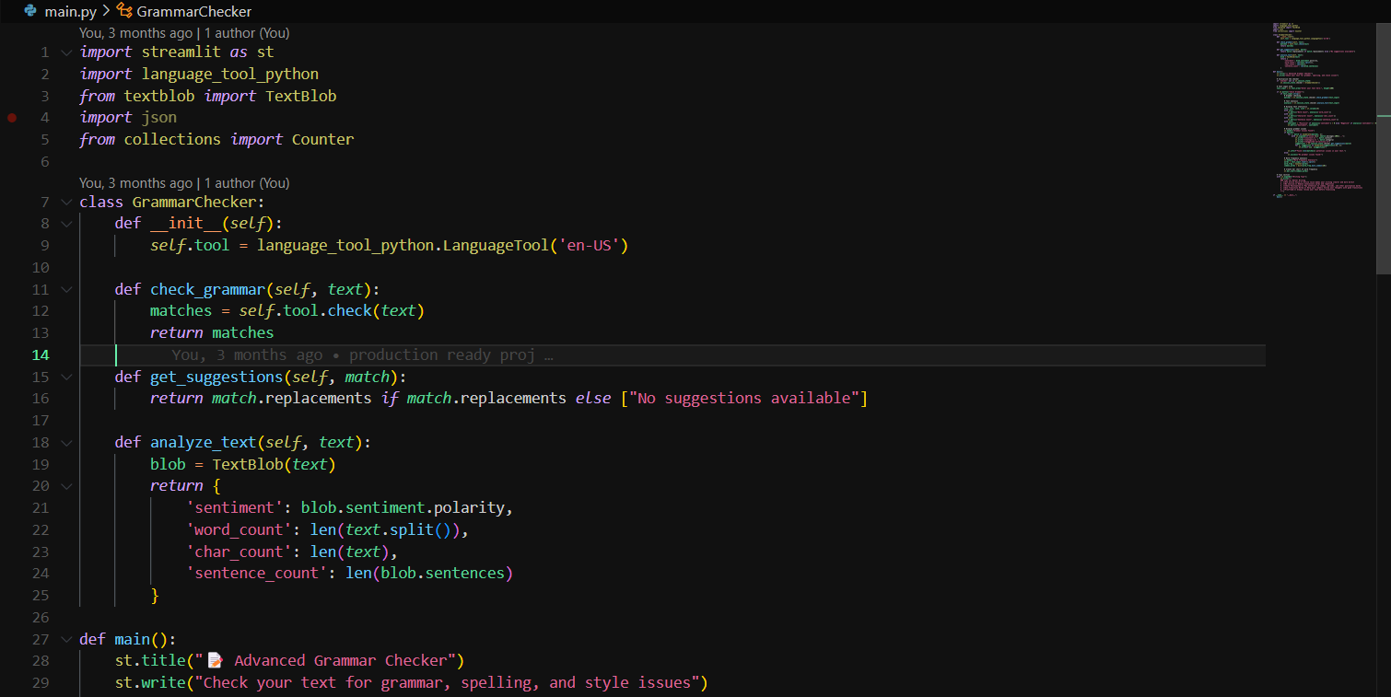

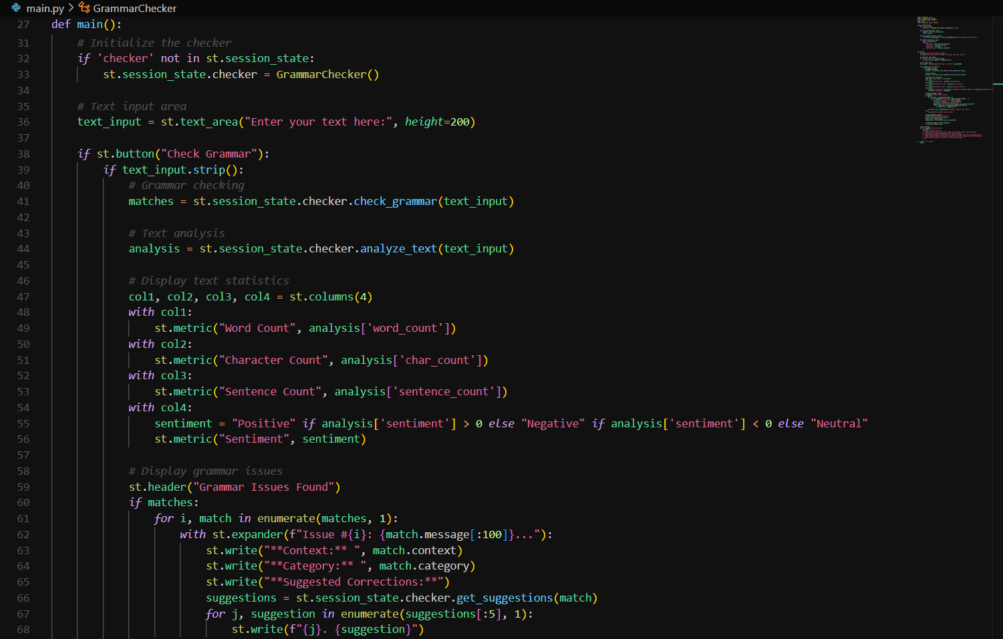

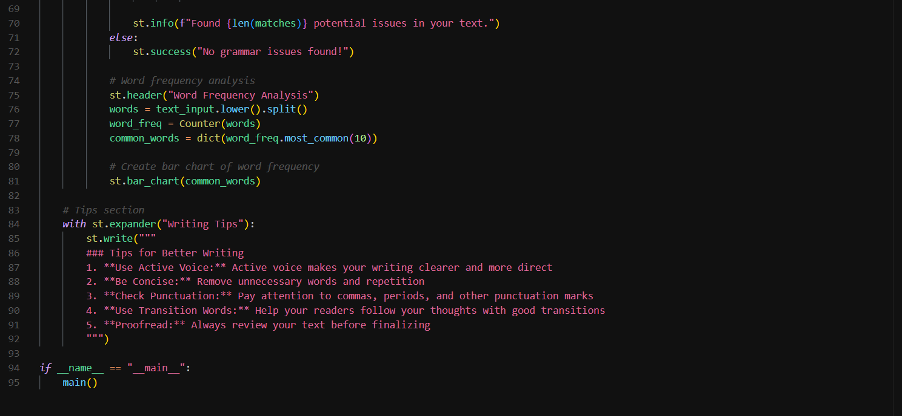

### System Snapshots

